1. [20 points] Discuss/explain the meaning of the term conducting airways. Discuss/ explain the physiological function(s) of the conducting airways.

The conducting airway are the section of the respiratory tract in which air goes in and out, it is a two-way traffic: during inspiration air from the atmosphere is brought into the lungs and during expiration air movement is in the opposite direction.

The conducting airways can be divided into upper and lower airways:

* upper airways (nose, mouth, pharynx, sinuses, larynx): warm, humidify and clean the inspired air
* lower airways (trachea, bronchi, bronchioles, terminal bronchioles): do not directly participate in gas exchange and instead allow bulk flow of air to areas which are responsible for gas exchange

1. [20 points] Discuss/explain the physiological mechanism(s) by which and the location(s) at which particulates in atmospheric air are removed before they reach the alveoli AND discuss/explain the fate of such particulates that do reach the alveoli.

Dust and other particulate matter are removed by nasal hair in the nostrils and by nasal turbinates (three continuous ribbons of tissue into the nasal cavity) which break up the flow of air, causing large particulates in atmospheric air to drop out into the mucus which is expelled when we blow our nose. The epithelial surfaces of the airways, to the end of the bronchioles, contain cilia that moves the secreted mucus and particulates towards the pharynx where it passes into the esophagus to be digested (mucous elevator). The airway epithelium also secretes a watery fluid upon which the mucus rides freely. In addition, constrictions of the bronchioles in response to irritation helps to prevent particulates and irritants from entering the sites of gas exchanges.

If particulates reach the alveoli, there are macrophage cells present in the alveoli which destroy inhaled particles and bacteria (similar macrophages are present in the airways).

1. [20 points] Discuss/explain the anatomical/physiological mechanism(s) by which air is moved from the atmosphere into the alveoli during inspiration, and from the alveoli to the atmosphere during expiration.

End of expiration/beginning of inspiration:

At the end of expiration, alveola pressure (Palv) is the same as the atmospheric pressure (Patm): Palv = Patm, there is no pressure gradient thus there is no airflow. The lungs are held open, the transpulmonary pressure balances chest wall pressure. During tidal breathing, inspiration is initiated by the neurally induced contraction of the diaphragm, its dome moves downward into the abdomen, enlarging the thorax.

Mid-inspiration:

As the thoracic cavity enlarges, the chest wall moves slightly farther away from the lung surface. As a result, the volume of the pleural space increases since the parietal pleura is attached to the chest wall. The visceral pleura pulls closer to the parietal pleura, which pulls the surface of the lung, the volume of the lung expands. The enlargement of the lungs causes an increase in the sizes of the alveoli throughout the lungs, decreasing Palv. The pressure difference between Patm and Palv, (Palv < Patm), causes a bulk of air from the atmosphere through the airway into the alveoli.

End of the inspiration/beginning of expiration:

At the end of the inspiration, the chest wall is no longer expanding (transpulmonary pressure is balanced by the elastic recoil of the lungs). There is no longer pressure differential (Palv = Patm) and no air flow. At the end of inspiration, the motor neurons to the diaphragm reduce their firing, so the diaphragm relaxes, start to recoil inward causing the thoracic cavity to passively recoil to its original dimensions.

At mid-expiration:

As diaphragm and chest wall start to recoil inward, the intrapleural pressure increases (Pip becomes less negative), the transpulmonary pressure decreases, the elastic recoil is greater and the lungs recoil, air in the alveoli becomes temporarily compressed, Palv becomes greater than Patm and air flows out.

End of expiration:

As the recoil of the lung goes on, the air inspired during the resting inspiration-expiration cycle is pushed out, and the cycle starts again.

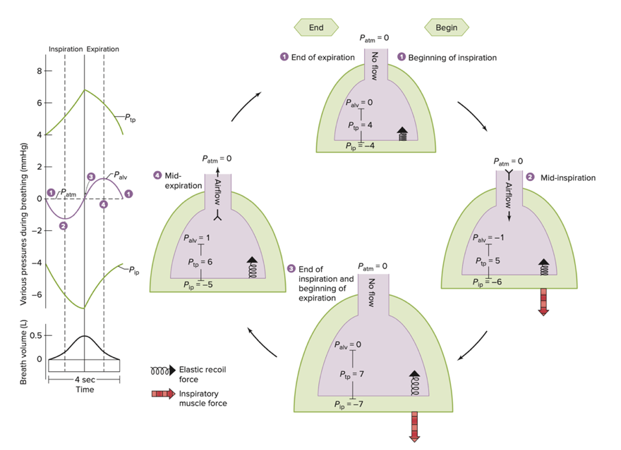

VSL[15] Fig.13.13

1. [20 points] What are the physical factors that directly determine airway resistance (to the flow of air)? Of these factors, which are under physiological control for the purpose of affecting airway resistance?

Physical factors which determine airway resistance to the flow of air (as described in module 11 – video 5 – slide 3):

* Lung volume:

Airway resistance decreases as long lung volume increases. At higher lung volume the parenchyma embedded in the airway, stretches it open and the airway tends to become a bit larger, the resistance drops a bit. When the lung is compressed, the parenchyma presses on the walls of the airway, and tends to reduce the diameter increasing the resistance.

* Neurohumoral agents:

There are smooth muscles surrounding the bronchioles. When these muscles are contracted, they constrict the bronchioles, the resistance is increased. And when these muscles are relaxed, they allow to increase the diameter of these bronchioles reducing the resistance to air flow. The bronchiole radius is under physiological control and determined by autonomic neural stimulation and/or by levels of circulating hormones.

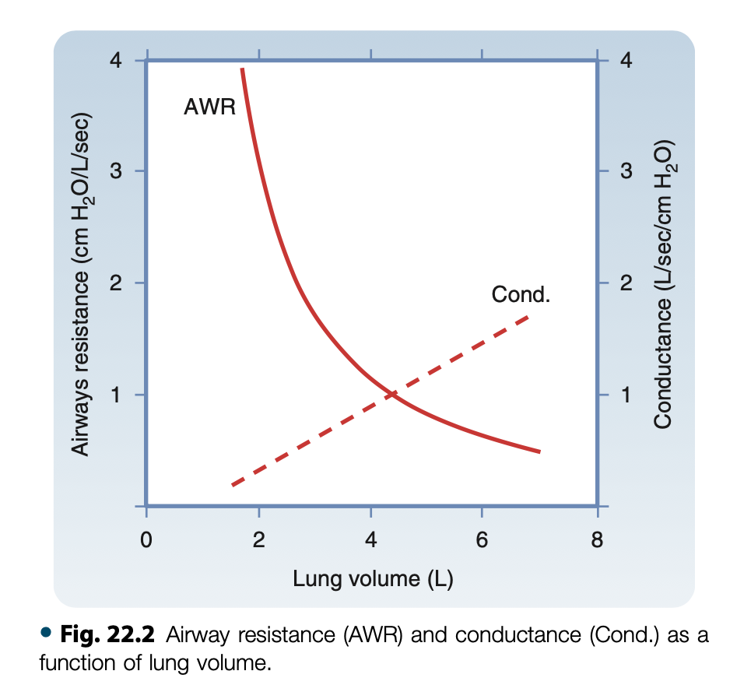

From B&L[7] p.458: AWR decreases as lung volume increases.

1. [20 points] Discuss/explain the mechanism(s) by which and the location(s) at which forced expiration affects airway resistance.

During an expiration, the pleural pressure (*P*PL) rises and causes the alveolar pressure (*P*A) to exceed the downstream pressure at the airway openings. Because alveolar pressure exceeds atmospheric pressure, gas begins to flow from the alveoli to the mouth.

However, in forced expiration, the thoracic cavity further reduces in size compared to quiet expiration, leading to a greater degree of compression of the lungs. And pleural pressure (*P*PL) can actually exceed the pressure in the airway. Compression starts at the equal-pressure point (EPP) in the cartilage-free airways within the lung (at a certain point between the alveoli and the mouth the forces that expand the airway equal the forces that tend to collapse).

Beyond the equal pressure point the driving pressure falls below the external pressure, and the bronchi are compressed (fig C below). Greater effort (↑ *P*PL) results in greater compression (↓ radius) with *no change* in air flow (this phenomenon is called dynamic airway compression with airway collapse).

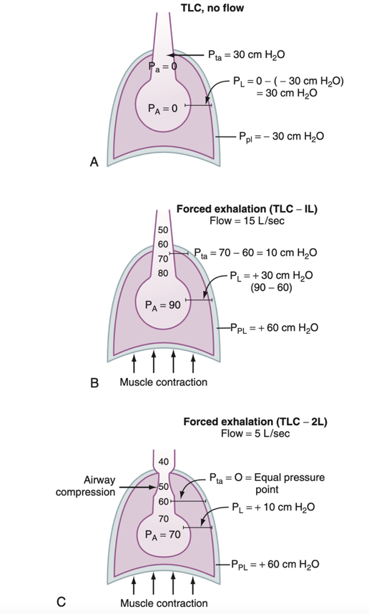

B&L[7] Fig 22.5 p.461